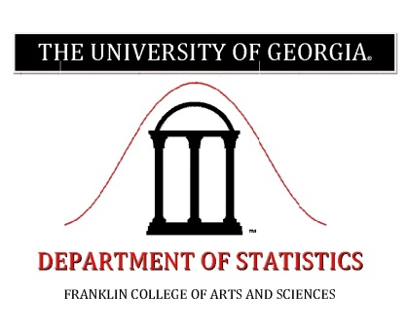

**Nonparametric Estimation of a Two-component Mixture Model with application to Multiple Testing**

We consider estimation and inference in a two-component mixture model where the distribution of one component is completely unknown. We develop methods for estimating the mixing proportion and  
the unknown distribution nonparametrically, given i.i.d. data from the mixture model. We use ideas from shape restricted function estimation and develop "tuning parameter-free" estimators that are easily  
implementable and have good finite sample performance. We establish the consistency of our procedures. Distribution-free finite sample lower confidence bounds are developed for the mixing proportion.

We next consider the problem of multiple testing when additional covariate information is available on each of the hypothesis tests. We propose a model for such data and develop likelihood based methods for estimating the unknown parameters. The theoretical properties of the proposed estimators are studied. We illustrate the practical efficacy of our methodology in applications in neuroscience, astronomy and genomics.

**Thursday, February 28, 2019**

3:30pm in room 102, Caldwell Building

**Bodhi Sen**

*Columbia University*

For more information, please contact us at:

Phone: 706.542.5232 E-Mail: stat@uga.edu

Parking is available in the North Campus Parking Deck.

For a UGA Campus map, please see: <http://aviary.camplan.uga.edu/CampusMap/Default.aspx>

Colloquium Series

**The University of Georgia**

**Department of statistics**